**Team 13 Thirteen South**

**Herman Cheng**

**Jiho Ryu**

**Justin Namoro**

**Joe Le**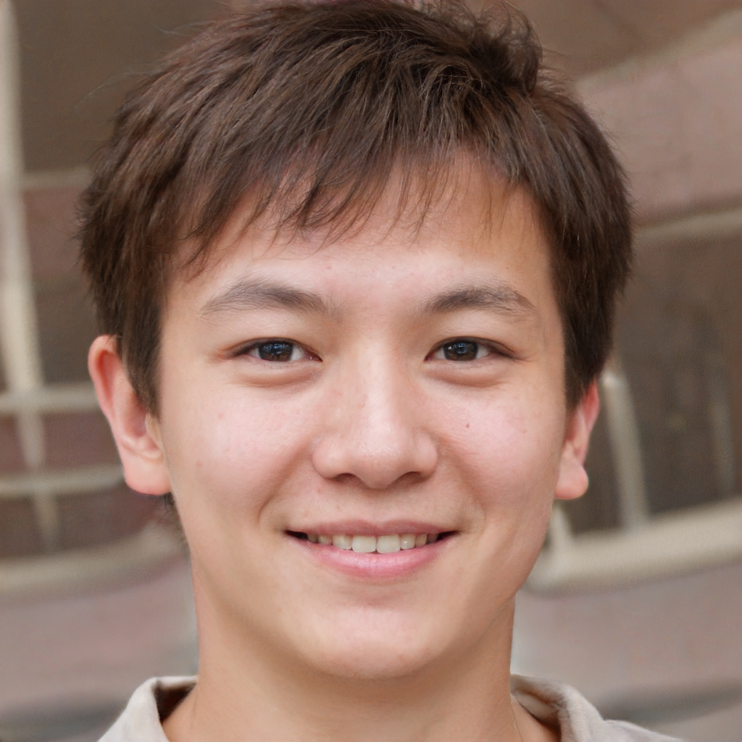

**Tam Nguyen**

1. **Personal details**

Name: Yuki Sano(佐野 友紀)

Age : 21

Martial state : single

Job : Dishwasher at Sushi Uomo

Education Level: BCIT student (freshman)

Income : part-time job, around $1,000 a month

Location : Richmond, BC

1. **Tagline**  
   - “I have a second life online, waiting for white truck-kun to hit me”
2. **Background info**

* Yuki Sano is a new student enrolling in BCIT. He applied and got accepted into 3d modeling art and animation. He is currently in his second semester. His favorite type of game genre is role-playing, such as MapleStory (class is battle mage). Living with his homestay, he dreams of living alone one day. Being in Canada for only 5 months he wants to learn more about the area and culture, especially for BCIT school life. Yuki is looking for different ways to learn but none of the results he is getting are interesting.

1. **Key behaviours**

* Often stops by electronics stores to look around for devices.
* Occasionally streams his play sessions on mixer, but can’t earn money.

1. **Key Goals and Motivations**

* Works hard in school to pursue his career as a 3D modeller for a game company
* To pay off his student loans
* Learn more about Canadian culture and BCIT school life.
* Since he started studying abroad, he values his family and his online friends (Maple Story)

1. **Frustrations**

* Struggles with balancing school, work, and social life.
* Has social anxiety.
* Financially unstable to afford more games/equipment.
* Microtransactions

**7. Technology use**

* Uses Discord as a main online messenger to communicate with his friends.
* Alienware laptop with logitech G815 mouse.



1. **Personal details**

Name: Abigail Chi Taylor

Age: 18

Marital Status: Single

Job: Part-time Subway sandwich maker

Education level : Highschool

Income: $10,000

Location: North Burnaby, BC

1. **Tagline**

“I like studying and working even in my free time.”

1. **Background info**

Abigail is currently in her last year of highschool and is thinking about pursuing nursing in BCIT. She occasionally likes to play games but her workload at school often keeps her away from any distractions. During her free time, she likes to hang out and go to cute cafes with her friends.

1. **Key behaviours**

* Tweets her current mood time to time
* Loves to eat and considers herself a foodie
* Uses VSCO to edit photos and uploads on her instagram accounts

1. **Key Goals and Motivations**

* Her main priority is finishing school and getting good grades for her future career as a nurse
* Motivation comes from volunteering at retirement homes
* Making her doctor parents proud of her

1. **Frustrations**

* Afraid of finding a bad job
* Indecisive with her future career path
* Not having enough time to hang out with friends and family

1. **Technology use**

* Smartphone (galaxy flip)
* Nintendo Wii
* Laptop (LG Gram 13)

**Notes:**

<http://theesa.ca/wp-content/uploads/2018/10/ESAC18_BookletEN.pdf>

* Canadian stats for gamers

<https://www.earnest.com/blog/the-demographics-of-video-gaming/>

* Gaming Demographics

<https://www150.statcan.gc.ca/n1/pub/71-222-x/71-222-x2018002-eng.htm>

* 73% of 15-24 year olds does part time because of school